Webscraping Project - Deepak Khirey

# Data Source

Suburban Motors is a prominent car dealership in Detroit area. It has distributorships of Chrysler, Ford, General Motors, Toyota etc.

There are 1000+ cars in the inventory and their prices change every day based on demand and stock. There are dealer discounts on MRP. Hence it is very interesting to see the Price trend and Inventory trend. This may help buyers to decide when they can expect to get their dream car at lower price.

**For this project, I’ve scraped Suburban Ford Dealership’s website** [**https://www.suburbanford.com/new-inventory/index.htm**](https://www.suburbanford.com/new-inventory/index.htm)**.**

**I’ve taken dump of everyday car inventory from the website. Data is collected over 44 days from 20 September 2019 to 03 November 2019.**

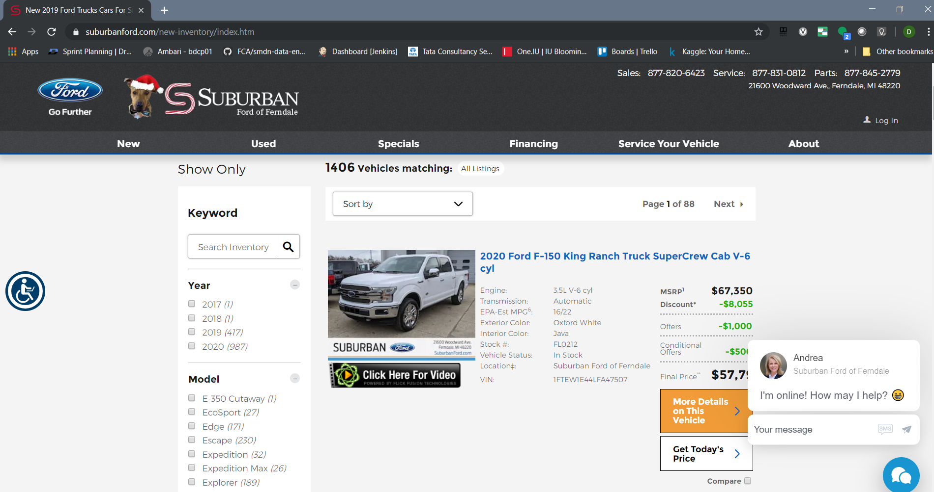

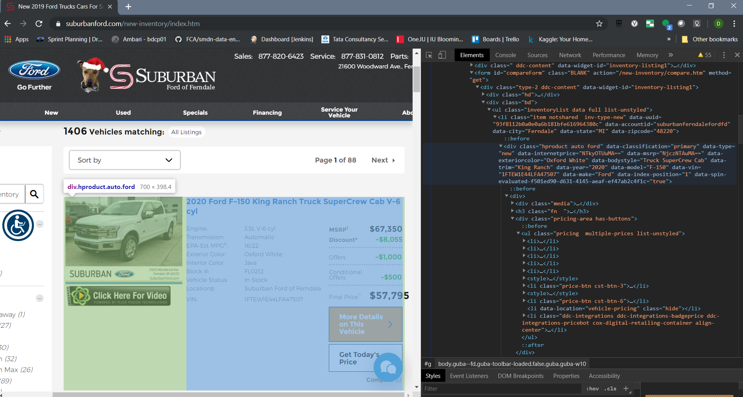

# Methodology

I have divided my coding efforts into 3 scripts –

## 1 Notebook 1 - Webscraping using Beautifulsoup

This notebook contains code to scrape Subarban Ford website "[https://www.suburbanford.com/new-inventory/index.htm"](https://www.suburbanford.com/new-inventory/index.htm%22). This code is executed daily once to get car inventory data from website.

## 2  Notebook 2 - Data Cleanup and Aggregation

This notebook contains code for cleaning up scraped data, applying data types and writing to common CSV file containing all inventory.

## 3.  Notebook 3 - Data Visualization

This notebook contains code for interactive Data Visualization using Plotly. It contains visualization for Boxplot of Prices, Bar chart for Inventory volume and Heatmap for Volume and Prices.

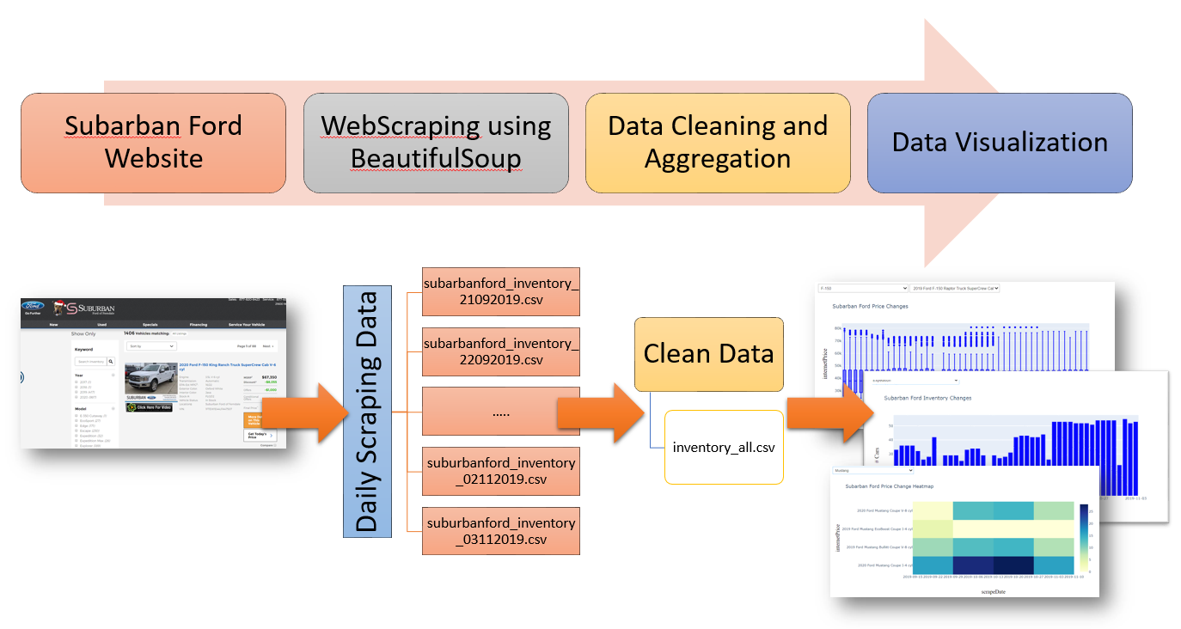

**Sample data Collected –**

**EPA-Est MPG6:,Engine:,Exterior Color:,Interior Color:,Location‡:,Stock #:,Transmission:,VIN: ,Vehicle Status:,abSub,finalPrice,internetPrice,msrp,name,scrapeDate**

"15/21,","3.5L V-6 cyl,","Shadow Black,","Charcoal Black,",Suburban Ford of Ferndale,"FI0343,","6-Speed Automatic with Select-Shift,",2FMHK6DTXJBA12592,"In Stock,","Discount*:$8,556",,"Price:$42,589","MSRP1:$51,145", 2018 Ford Flex Limited SUV V-6 cyl,21/09/2019

"27/29,","1.0L I-3 cyl,","Shadow Black,","Ebony Black,",Suburban Ford of Ferndale,"FI1225,","6-Speed Automatic,",MAJ3P1TE3JC205789,"In Stock,","Discount*:$1,241",,"Price:$22,754","MSRP1:$23,995", 2018 Ford EcoSport SE SUV I-3 cyl,21/09/2019

"24/27,","2.0L I-4 cyl,","Frozen White,","Ebony,",Suburban Ford of Ferndale,"FK0008,","8-Speed Automatic,",NM0LS7E27K1386260,"In Stock,","Discount*:$1,970",,"Price:$25,075","MSRP1:$27,045", 2019 Ford Transit Connect XL Van Cargo Van I-4 cyl,21/09/2019

"15/24,","5.0L V-8 cyl,","Shadow Black,","Ebony,",Suburban Ford of Ferndale,"FK0019,","6-Speed Manual,",1FA6P8CF7K5117803,"In Stock,","Discount*:$3,756",,"Price:$39,384","MSRP1:$43,140", 2019 Ford Mustang GT Coupe V-8 cyl,21/09/2019

"15/24,","5.0L V-8 cyl,","Oxford White,","Ebony,",Suburban Ford of Sterling Heights,"FK0023,","6 speed manual,",1FATP8FF9K5108793,"Available in extended inventory,","Discount*:$5,970",,"Price:$40,000","MSRP1:$45,970", 2019 Ford Mustang GT Premium Convertible V-8 cyl,21/09/2019

# Data Visualization

1. **Boxplot for Price Changes -**

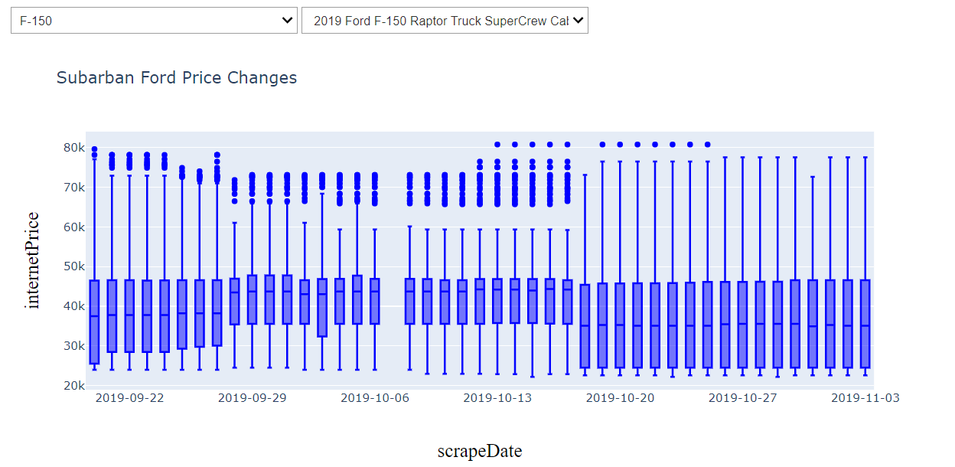

1. **Bar chart for daily Inventory Volume changes**

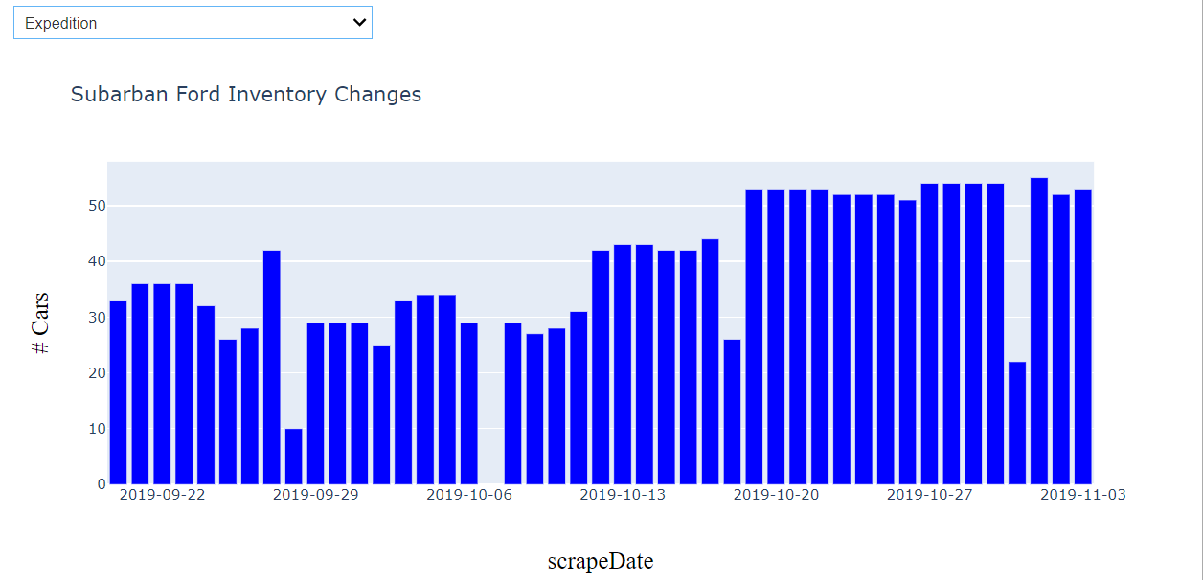

1. **Heatmap for Price changes modelwise**

